Introduction

Purpose and Scope
Power State Plug-in API provides the adaptation plug-in interface to allow the HW Resource Manager Server to update the P&S (Publish and Subscribe) power state keys in HW Resource Manager Power State API. These keys provide up-to-date information on the charging status, battery level and battery state of the device.
Any application may subscribe to the P&S keys that are updated to receive notifications of any change in state.
Licensees must implement this interface to allow correct power state information updates of the device. If the adaptation implementation is not present, the HW Resources Manager will not update the P&S power state keys in the HW Resource Manager Power State API which will result in the client application being unable to correctly retrieve the power state information.

List of required interfaces
As this is an ECom plug-in, the ECom framework is required.

Technical specification

Type of interface
This API is implemented as an ECom plug-in and hence is loaded through the ECom framework.
When constructed, a pointer to a callback interface (MHWRMPowerStatePluginCallback) is provided. Plug-in may then call the single callback notification method NotifyStateChange() to inform of any changes in state.

Interface class structure
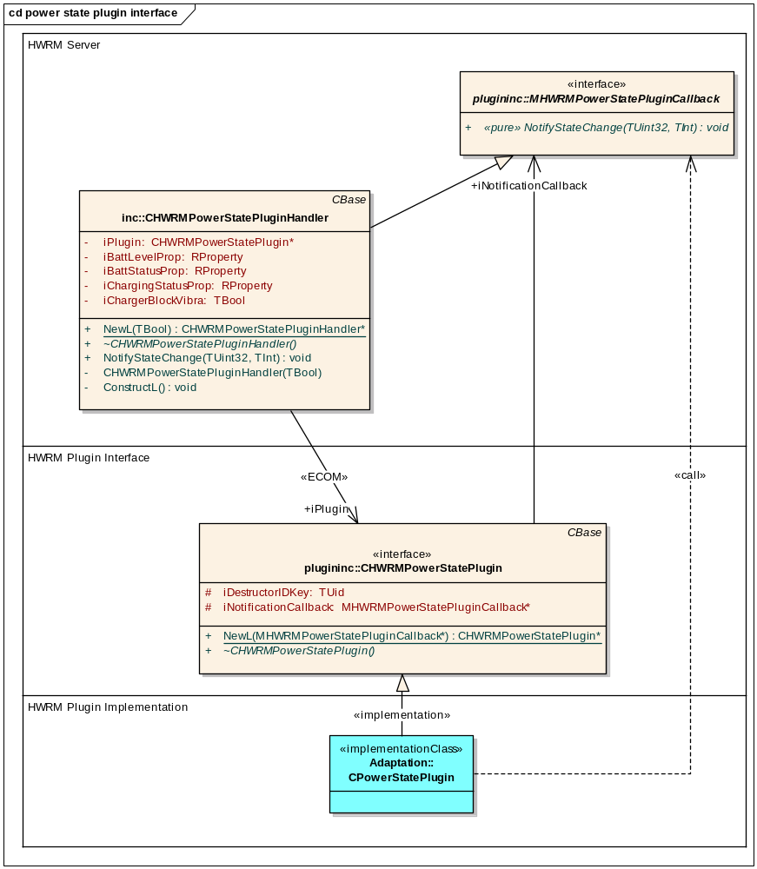
Figure 2.1 Interface class structure
Figure 2.1 shows the interface structure of this API.
The CPowerStatePlugin class represents the actual implementation of the plug-in that is responsible for updating the power state via the callback interface. This should be derived from the CHWRMPowerStatePlugin class that handles instantiation of the implementation via ECom.
CHWRMPowerStatePluginHandler from the HW Resource Manager Server implements the MHWRMPowerStatePluginCallback interface class and creates the instance of the plug-in. A pointer to the MHWRMPowerStatePluginCallback is passed to the plug-in to allow notifications of power state changes to be indicated via the NotifyStateChange() method.

Usage

Protocol
Implementation of the plug-in must be derived from the CHWRMPowerStatePlugin base class. When instantiated by the HW Resource Manager Server a pointer to the MHWRMPowerStatePluginCallback interface class is provided. It is this interface that provides the callback method required to send notifications regarding the power state.
The plug-in is responsible for monitoring the device HW via some product specific interface. Once a state change in the battery level, battery status and/or charging status is detected by the plug-in, it must call the synchronous MHWRMPowerStatePluginCallback method NotifyStateChange() with the appropriate key type and value.
Once called the notification method forces the HW Resource Manager Server to update the appropriate P&S keys and hence all clients/applications subscribing to the keys are notified of the new state.

Error handling
The single notification interface method does not provide a mechanism for returning any error codes. Reason for this is that the only cause of failure would be an error in the P&S update, and in this case there is no action the plug-in can take to either report or rectify the situation.

Memory overhead
HW Resource Manager memory overhead is implementation dependant.

Extensions to the API
Any additional power state information that may be required could be easily added to this API via an extra P&S key. The plug-in implementation would then be able to update the additional key value through this API.

Plug-in configuration
The Power State Plug-in API is implemented as a standard Symbian OS ECOM plug-in. For further ECOM implementation guides refer to the Symbian documentation. The HWRM server restricts the loading of the ECOM Power State plugin to ROM only DLLs.
Note: As is usual with the ECom architecture, special care must be taken when writing the resource files. When implementing this plug-in the resource file must implement the interface_uid of 0x10205042, the default_data must equal HWRMPowerState and rom_only must equal 1.
Without these conditions the plug-in implementation will not load correctly.
Here is an example resource file demonstrating the correct values (pay special attention to the attributes show in red):

#include "RegistryInfoV2.rh"

RESOURCE REGISTRY_INFO theInfo
{
resource_format_version = RESOURCE_FORMAT_VERSION_2;
dll_uid = 0x12345678;
interfaces =
{
INTERFACE_INFO
{
// UID of Power State interface implementation
interface_uid = 0x10205042;
implementations =
{
IMPLEMENTATION_INFO
{
implementation_uid = 0x12345679;
version_no = 1;
display_name = "Power State plugin";
default_data = "HWRMPowerState";
opaque_data = "";
rom_only = 1;
}
};
}
};
}

Example
An example of how the plug-in interface may be implemented is shown here:
In the header file:

#include <HWRMPowerStatePlugin.h>

class CPowerStatePlugin : public CHWRMPowerStatePlugin
{
public:
static CPowerStatePlugin* NewL();
~CPowerStatePlugin();

// Update battery state, called by domestic OS when battery level changes
void UpdateBatteryLevel( TInt aLevel );

. . .

private:
CPowerStatePlugin();
void ConstructL();

};

CPP file:

#include "PowerStatePlugin.h"

. . .

void CPowerStatePlugin::UpdateBatteryLevel( TInt aLevel )
{
// Battery level has changed in domestic OS

// Parameter aLevel must be mapped from TInt to corresponding
// level (0 to 7) as defined in HWRMPowerStateSDKPSKeys.h
EPSHWRMBatteryLevel batteryLevel;

// map aLevel to batteryLevel
. . .

// Notify HWRM of change in state to update appropriate P&S key
iNotificationCallback->NotifyStateChange(KHWRMBatteryStatus, batteryLevel);
}

Further Information

Open Issues
None

Glossary
Term | Definition
API | Application Programming Interface
ECom | EPOC Component Object Model
HW | Hardware
HWRM | HW Resource Manager
OS | Operating System
P&S | Publish and Subscribe
ECom | Symbian OS mechanism to load alternative implementations of a plug-in at run-time.
Publish and Subscribe | Symbian OS mechanism to allow global variables to be set and retrieved.

